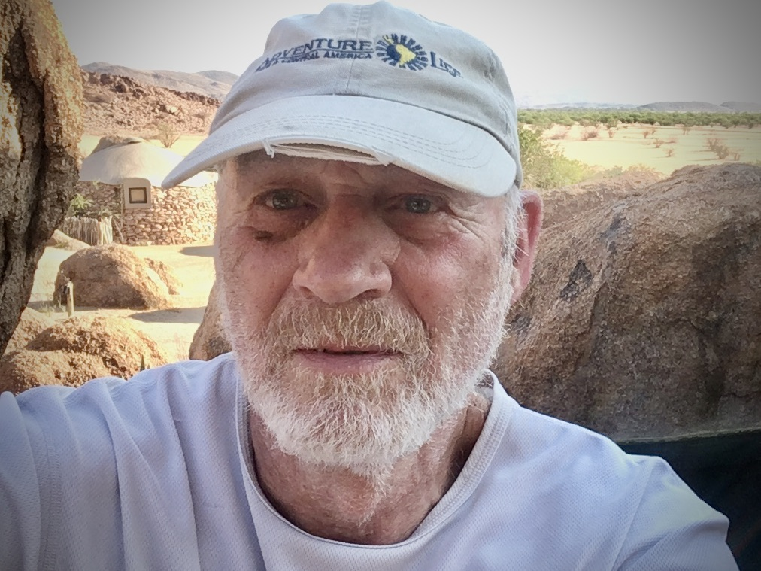

Ira Stahl – Nominee for Director

Hello everyone.  I am a native New Yorker born and raised in Brooklyn, attended public schools and graduated from Brooklyn College. For 35 years I was a New York City schoolteacher and administrator working primarily with special needs students. I have been an outdoor enthusiast my entire life, hiking, backpacking, kayaking and canoeing. In addition, I have participated in many service trips with the Sierra Club and the AMC. I have been hiking in Harriman Park for many years and only recently discovered Nawakwa. Since joining about 5 or 6 years ago, I have participated in the spring and fall cleanup weekends, attended meetings and volunteered whenever help was needed. I am currently the Conservation Committee chairperson.There are two main things I am focused on for Nawakwa. One is to participate in activities to improve the environmental and conservation needs of Harriman State Park and the world in general. The other is to assure that Nawakwa continues to be a place to enjoy a natural setting for relaxation, socialization and friendship, by ensuring that the physical plant is properly maintained, and that people enjoy the setting with enough rules to assure everyone’s enjoyment of the camp without being overly restrictive. To fulfill these goals, we need to try to increase membership participation and proactively seek new members. - Ira