Candidates for Nawakwa Outdoor Association of New York, Inc. Elections 2022

**For Board Chair – Ray Kozma (Current NOANY Board Chair)**

Our recent disassociation from ADK has given us an opportunity to renew and refashion ourselves as the Nawakwa Outdoor Association. I see the next two years as a time in which we can re-organize and update ourselves as a club, building a strong foundation so that we may thrive in the years ahead.

Our nearly one hundred-years of history and traditions, our spirit of volunteerism and camaraderie, joined with the increase in new and enthusiastic applicants and members, provide us with ways to revitalize the club. In my many years of membership, I can attest to the strength, vitality, generosity, and talent of our members. As the Board Chair, working with all our Board and Committee members, I will strive to draw upon all these dynamics in moving us forward as the Nawakwa Outdoor Association of New York.

**For Treasurer – Suzanne Rocheleau (Current NOANY Treasurer)**

Suzanne has been an active member of Nawakwa Outdoor Association (NOA) since 2011. She is currently one of the officers of the NOA Board of Directors and has been serving as Treasurer since January 2015. Suzanne has been active in hosting weekends and in joining in on the Work Weekends each year.

She has been employed in Financial Services for the duration of her career. Her profession has involved a range of roles starting with Mutual Fund Management, followed by Fixed Income Trading, Investment Banking and currently Wealth Management Services for UBS.

Suzanne is an active hiker, cyclist, and tennis player. She is also active on the Boards of Toastmasters, Inc., and her Northeastern University Alumni organization.

**For Director – Susanne Flower (Current NOANY Director)**

I have been a Nawakwa keyholder for 18 years, have hosted many weekends and holidays, edited the Trail Marker in 2006-07, served on the nominating committee and assisted in the revision of the hosting guidelines. I am running for my third term on the Board.

My goals as a Board member are to maintain the club’s stated objectives while ensuring that we continue to grow and become an organization that is relevant to new generations of members. To achieve these goals, I will continue to focus on our financial health, the safety and integrity of our physical facilities and policies and procedures that promote safety, inclusion, and the protection of our environment.

I volunteered to run for a position on the Board in 2018 because of my belief that I have a responsibility to participate in and support organizations in which I maintain membership. That continues to be my philosophy.

**For Director – Alex Wilke (Current NOANY Director)**



Alex is a retired college professor who has been a member of the Nawakwa Outdoor Association since 1985.

He enjoys hiking, snowshoeing, and kayaking.

An avid artist, he can often be seen around camp with his oil paints and easel.

He lives in Moorestown, NJ., with his wife, Janet.

**For Director – Carol Burns (Current NOANY Director)**

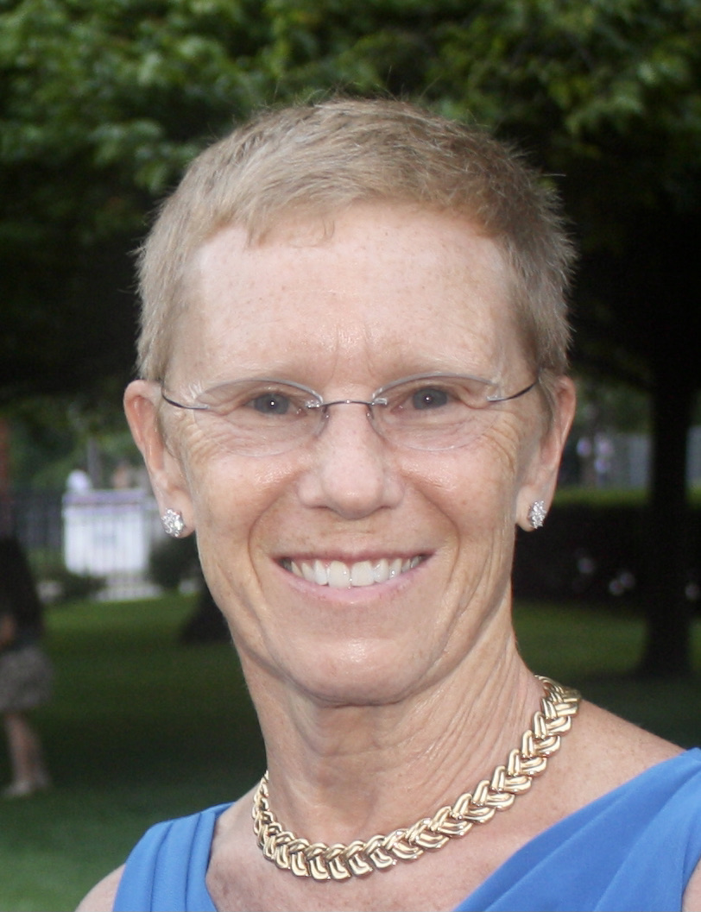I have been a Nawakwa member since 2001. Bill and I maintain a section of the Appalachian trail for Nawakwacalled Agony Grind.

I was a Water Safety Instructor at a Boy Scout Camp on Staten Island and supervised the camp waterfront. I would like to help organize the waterfront at Nawakwa to maintain safety standards. All members need to be familiar with the safety equipment.

I was an Administrative Assistant to the Medical Director of a New York City Health & Hospitals Corporation hospital.

I have served on the Nawakwa Board for one year and I look forward to serving again. Thank you for your consideration to vote for me in the election.